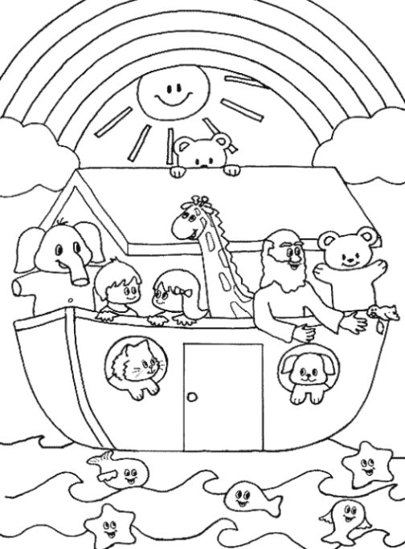 | God said “ I have set my bow in the clouds, and it shall be a sign of the covenant between me and the earth.”  Genesis 9:11

Below are some activities children and youth can use at home. They are all related to the Readings for Feb 21, 2021

For Younger Children:
Video: Crossroads Kids Club » God’s Story: Noah

Children’s Sermon: Noah: A rainbow of promises
Children's Sermons from Sermons 4 Kids | Object Lessons...

The next 6 pages are designed for younger children.
All pages are from sermons4kids.com

For Middle School and High School aged youth
The last 2 pages are a bible study based on the Gospel reading for the day.

Video: JESUS, (English), The Devil Tempts Jesus - YouTube

Group Activities

CHASING A RAINBOW:ONE child will have a large cut out of a colorful rainbow from poster board. This will be a game of tag. Other children will run after the rainbow until someone tags the "rainbow" and then that child will hand the rainbow to the next child and continue to run and tag each other, as time allows.

RAINBOW DROPS:This will be played like "pin the tail on the donkey" but the teacher will use the same rainbow cut out as used in the first game of RAINBOW TAG.. and will place the rainbow on the wall. Children will be blindfolded and will take turns pinning a cut out rain DROP onto the rainbow. The teacher can give points for the raindrops pinned on each color -- such as the red could be 10 points, the blue could be 20 points, the yellow could be 5 points, etc.

RAINBOW ARCH HUNT:The teacher can have many curved and colored arches for a rainbow hidden around a designated area. The children can each go to hunt for one rainbow arch and bring it back to the classroom and tape together to form a rainbow. The child who finds a rainbow arch with today's Bible verse or words such as GOD IS FAITHFUL IN KEEPING HIS PROMISES, will receive a bonus treat and place that rainbow arch at the top of this rainbow.

RAINBOW HANDS:Children can trace and cut out 5 of their own hands and color each hand in a different bright color of magic marker or crayons. Then the children will tape the hands together in an arch formation and glue or tape to a piece of paper. Children can write words from today's lesson on their hand rainbow.

RAINBOW FINGER PAINTING:Give each child a piece of paper and some blobs of finger paint to form a rainbow picture. Use finger to write, PROMISES, or other words from today's lesson, on their finger painting artwork.

WEDDING RING:Let children weave a ring with plastic string or just take thin paper and wrap around child's finger and tape, after children have colored their ring paper or use colored construction paper. Remind children of the illustration of the wedding band and the reminder of a very special promise that was made.

ARK ANIMALS:After the teacher has told the story about Noah and the ark, children can be given small pieces of paper (2"x2") to draw animals on each paper. Provide children with an ark shape piece of construction paper to tape their animals to and let children tell the story again together, as the teacher asks questions about the story. Make sure children have several pieces of paper in order to make TWO of the same type of animal for each animal they draw.

ANIMAL FINGERPRINTS:Provide children with ink pads and construction paper. Children can make finger prints on an ark shaped piece of construction paper and then add head or legs or tails to their "animal prints". Write words from today's lesson on the animal page, to remind children to thank GOD for being so faithful to keep His promises.

SING A SONG:Arky, Arky; THE B-I-B-L-E
RAINBOW COOKIES... the teacher can give children frosted cookies and let children share the little gel tubes of colored frosting to pass around and form a rainbow on each of their cookies. If time allows and there are enough cookies, children could decorate two or more and share the cookie as they also share the story today with someone else.

