Below are some activities children and youth can use at home. They are all related to the Gospel reading for November 22nd

For Younger Children:
Video

https://www.youtube.com/watch?v=iWSkdx-XwWY&list=PL2BsRumMAl51zB3UKYtkoeakubKeBJrnv&index=33

Children’s Sermon: Thanks Living
https://sermons4kids.com/thanks_living.htm
The next 5 pages are designed for younger children.
All pages are from sermons4kids.com

For Middle School and High School aged youth
The last 2 pages are a bible study based on the Gospel reading for the day.

Video: https://www.youtube.com/watch?v=qzvP0m2Nimk

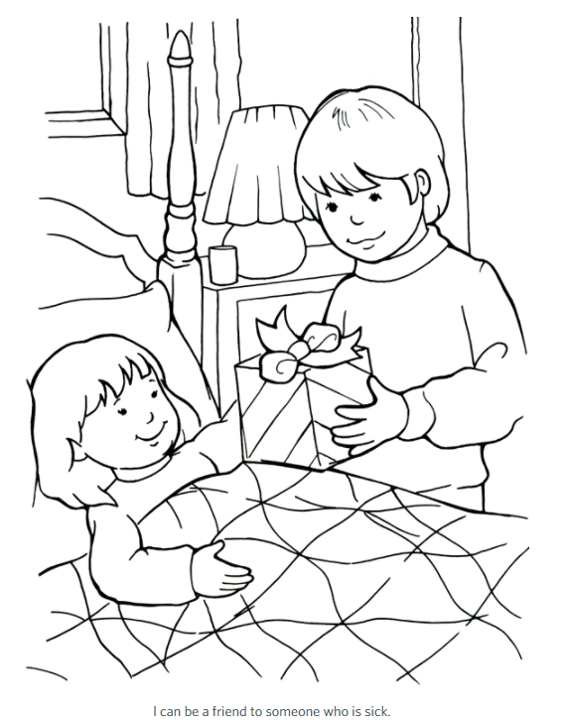

Group Activities

THANKS LIVING CHARADES:Divide the children into teams and let each team act out a charade of something they can do to help someone in need. The teacher should write some ideas on slips of paper that the children can draw out of a bag.

SNACK PACKS FOR OTHERS:Let the children put together some "snack packs" to give to some hungry people in their area. The teacher can provide zip lock bags, crackers, pudding cup, fruit cup and a juice pack or similar foods. Let the children walk around the table and make snack packs to be given out to the hungry.

A MOMENT OF THANKS CONTEST:Let the children volunteer to play against another player for one minute. Ring a bell or have some other signal to start. Each child will name as many things as they can think of for which they are thankful. There will need to be a score keeper/listener for each player. When one minute is up, see who has the most things for which they are thankful on their list. This can be done as teams as well, if teacher desires.

TIMED FOOD DRAWING:Give each child a piece of construction paper and markers or crayons. At the start of a timer, the children will draw as many kinds of food as they can think of that they enjoy eating. After one minute, the children will pass their papers to the child to their right. The teacher will set the timer again for one minute for the next child to draw the foods that they like to eat. Continue this activity as time allows. When the child's paper has made the complete cycle, each child will write FEED THE HUNGRY at the top or around the edges of their paper. Let children know that many children don't get to eat all of those things and they go hungry many days. Let children have a prayer time together for those hungry boys and girls.

LAUNDRY BASKET OF THANKS:Before class begins, the teacher will place items all around a designated area for the children to collect and place in a laundry basket. Suggested items might be canned foods, a mini vacuum, clothes, toys, stuffed pets, cleaning products. When all of the items have been found and placed in the laundry basket, the teacher can talk about each item and discuss ways that they might show their thanks to their parents. (Helping fix dinner, picking up their toys, helping clean house, raking leaves, keeping their room clean.)

THANKS ENVELOPE WALL HANGING:Give each child can an envelope that opens at the top of the narrow end. The children will decorate the envelope stickers and words from today's lesson written in bright colors. Attach the envelope to a piece of colorful poster board or construction paper to hang in their home. Give children blank strips of paper for each family members to write words of thanks written to another family member and place in the decorated envelope each day. These can be read at the end of the month together as a family!

THANKS COLLAGE:Let the children cut out pictures from magazines of people showing kindness to others. Glue the pictures onto a piece of construction paper to create a collage. Cutting out words that show kindness to others can also be added to the collage. Cutting out a different color of construction paper for strips that can be glued around the edges to form the picture collage border will add a special touch.

SING A SONG:Share His Love; Jesus Loves the Little Children

