Below are some activities children and youth can use at home. They are all related to the Gospel Reading for August 2nd

For Younger Children:
Video :
https://www.youtube.com/watch?v=CCA4oivfSYk
This is a fun song about the lesson :
https://www.youtube.com/watch?v=yCcp1N_CfN4

Children’s Sermon
Option 1: https://sermons4kids.com/feeding_5000.htm (Feeding 5000)
Option 2:
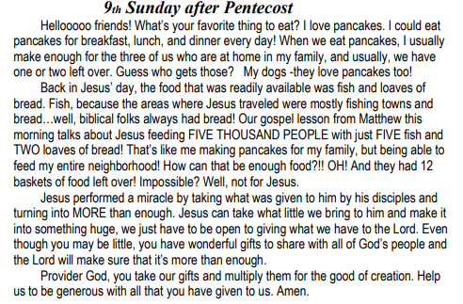

The next 6 pages are designed for younger children, but you might be able to play some of the games with older children as well.

For Middle School and High School aged youth
The last 2 pages are a bible study for older children/youth

Here is a link for older youth, to videos related to the Gospel Lesson and the Bible Study. The first video shows the story, the second is some explanations and thoughts on the story:
https://www.bible.com/videos/25-jesus-feeds-the-5-000-from-jesus-film-project
https://www.youtube.com/watch?v=RRhcAM41ZsE

Group Activities for Scripture Reading:Matthew 14:13-21

BREAD AND FISH: Let the children pass around a homemade loaf of bread and each child can take a piece and place in a small sandwich bag that they have decorated with stickers. Then let the children each take a handful of "goldfish" crackers and talk about the lesson!

ROCK ART: Let each child pick out a smooth rock and paint it and write LITTLE IS MUCH WHEN GOD IS IN IT!

BUBBLES PLAY TIME:Give each child a small bottle of bubble blowing liquid and tell them to see how MUCH can come out of a very small bottle of bubbles. Tell children that ALL those bubbles can represent all the things that GOD can do when HE is in our lives!!

GROWING LUNCHES:Set up a table with a variety of items (raisins, fish crackers, M&M's, cookies, etc) and have children decorate a paper lunch bag with stickers and markers with LITTLE IS MUCH WHEN GOD IS IN IT, or FEEDING THE 5000. Let children make their "lunches" GROW by taking a little of each item on the table.

BASKET FILLING:Have the children to make small baskets out of a sheet of construction paper by folding in the sides and adding a handle. Let them fill their baskets with small items that the teacher provides. Encourage the children to put a few things in their baskets that they could share with someone else while telling today's story!

TIE DYE SHIRTS:Provide inexpensive t shirts that have been tie dyed. Let the children put cardboard between the 2 layers and use fabric markers to write LITTLE IS MUCH WHEN GOD IS IN IT.

BREAD AND FISH DRAWING:Give the children markers an paper to draw a large piece of bread and some fish and write LITTLE IS MUCH WHEN GOD IS IN IT. Write today's Bible verse on the piece of bread in the picture!

VISOR ART:Using some inexpensive visors you can get from a craft store, let the children write LITTLE IS MUCH WHEN GOD IS IN IT on them and wear their visors while telling people how Jesus fed the 5000, etc.

SUNDAY SUNDAES:Give each child a small bowl or an ice cream cone and supplies to BUILD a Sunday SUNDAE! Tell the children that they will start with a little and watch their ice cream GROW! This will make a FUN summer treat to enjoy!

